Instructions for video recording audition piece
Thank you for your interest in auditioning for the Music Excellence strand of Urangan State High School's ACE Program. We are excited to review your talents and potential contributions to our community. Below are the basic instructions for submitting your audition materials:
- Introduction: Begin your audition email by introducing yourself. Please state your full name and the primary school you currently attend or have attended.
- Performance Piece: State the name of the piece you will be performing. This can be a musical instrument solo, vocal performance, or any other talent you wish to showcase.
- Multiple Performances: Students are welcome to showcase their abilities in multiple ways. If you play multiple instruments or have vocal abilities, feel free to include separate sections in your email for each performance. This will allow you to demonstrate a range of skills and talents.
- Length and Format: Please note that the audition video(s) should be between 30 seconds to 1 minute in length. The format for submission should be MP4 or MOV. (No larger than 33MB)
- Email Instructions: Please email your audition details to musicace@uranganshs.eq.edu.au. Include your introduction, performance piece information, and any additional performances you wish to showcase in the email body. Attach the MP4 file(s) of your audition video(s) to the email.

How to reduce video size while recording on an iPhone/iPad?
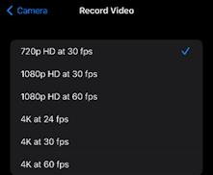
One of the easiest ways to compress a video on iPhone is to reduce its size in the filming phase. Simply record it at a lower resolution while shooting and your file size will automatically be smaller. Here’s how you can make videos smaller in under a minute on your iPhone:
Step 1: Open your iPhone Settings and click on Camera
Step 2: Under your camera go to the Record Video setting and
you’ll see it has a resolution and frame rate set.
Step 3: Simply go ahead and click on the resolution of your choice.
The 720p at 30fps is the lowest this iPhone offers and it’s quite the
space saver too.

How to reduce video size while recording on an Android Phone/Device?
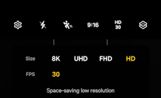
One of the easiest ways to compress a video on Android device is to reduce its size in the filming phase. Simply record it at a lower resolution while shooting and your file size will automatically be smaller. Here’s how you can make videos smaller in under a minute on your Android device:
Step 1: Open your Camera app
Step 2: Switch to Video mode
Step 3: At the bottom left, tap settings
Step 4: Next to resolution, select HD, 30

